**Pass Task 7 -**􀀁**Unit Testing the**

**Spell**

**Related Learning Outcomes**

**ULO1 – Explain the OO Principles**

This exercise demonstrated object encapsulation

**ULO2 – Use OO Language and Library**

Demonstrated class and constructor declaration, the use of conditional statements (e.g. 􀀂if􀀃), and assigning values to parameters. Uses of string assert, areequalignoringcase, by enable the nunit for testing the return of the string since I’m using the string assert, and using the are equal ignoring case which to check the expected and actual case.

**ULO3 – Design, Develop and Test using an IDE**

The code was developed using Xamarin Studio to build and run the program, as well as integrated debugging features to step and inspect values.

**ULO4 – Communicate using UML Diagrams**

I learned how to interpret a UML class diagram and write the related code.

**ULO5 – Describe Elements of Good OO Design**

The exercise demonstrated correct use of C# coding conventions.

**Screenshots**

[code running]

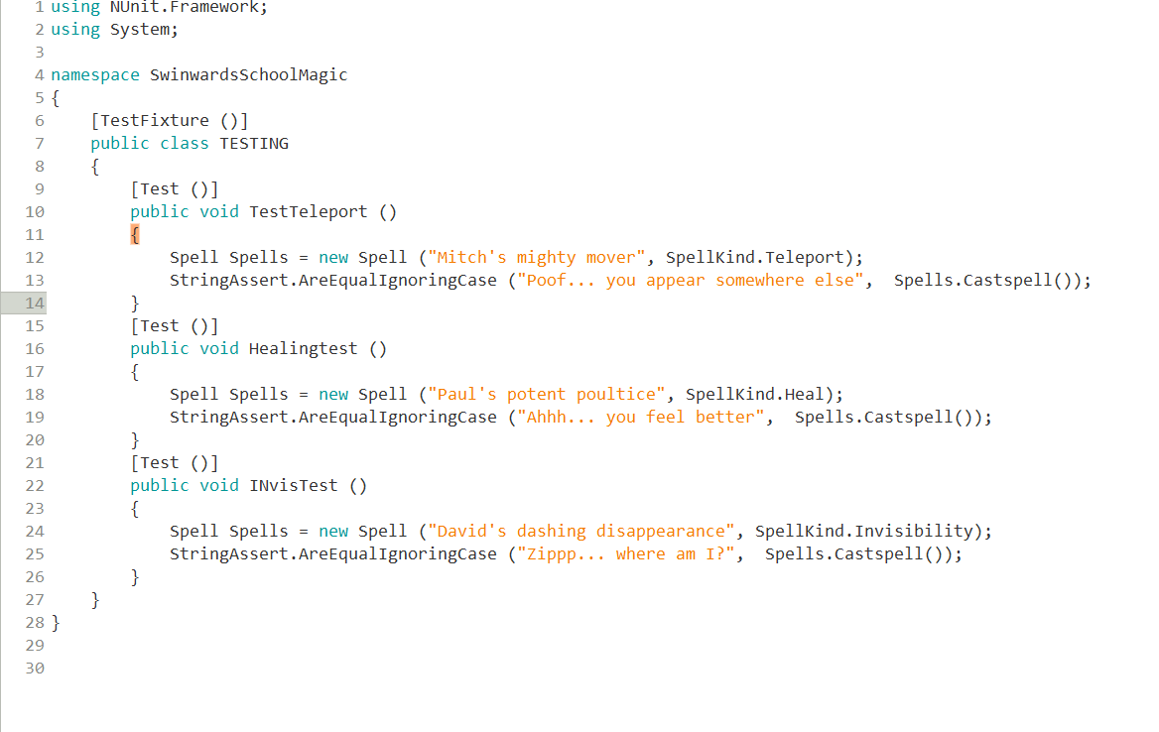

IDE

